Lincoln Memorial Day Observance Association
“Remembering the Price of Freedom”

The mission of the Lincoln Memorial Day Observance Association (LMDOA) is to plan, promote and organize Memorial Day Observances at WYUKA Cemetery, Lincoln Memorial Park, and the Veterans Memorial Garden. The LMDOA, founded in the 1950’s, is an organization comprised of local veteran organizations and associations.

The main goal of the LMDOA is to promote the true meaning and observances of Memorial Day. The LMDOA is striving to rekindle patriotism and pay tribute to our Country’s service men and women.

We would like to thank all of you who have taken time out of your Holiday weekend to be a special part of this Memorial Day Observance.

May the remainder of your Holiday be a safe and an enjoyable one.

God Bless America.

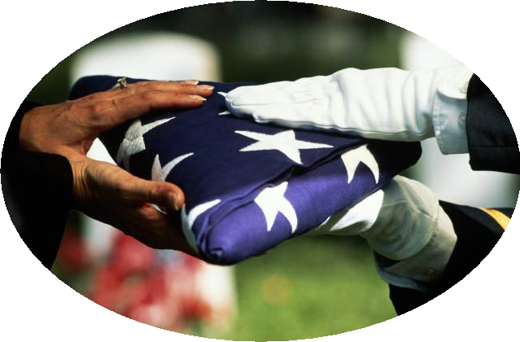

2013 Lincoln Memorial Day Association Officers

Co-Chair ~ Brendan Moore, American Legion Post #3
Co-Chair ~ Ed Hoffman, Veterans of Foreign Wars #3606
Parade Chair ~ Ron Lechner
Secretary/Treasurer ~ Amy Cink,

Sound System by: Midwest Sound & Lighting

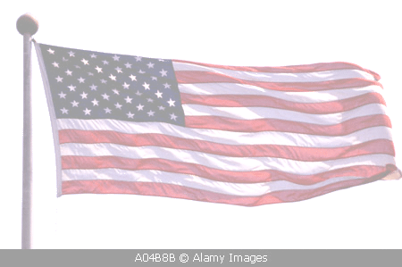
2013 Lincoln Memorial Day Observance Association Members
Memorial Day Observance

May 27, 2013

8/40 Lancaster Salon 92
8/40 Salon 832
American Legion Post #3 & Auxiliary
American Legion Auxiliary Lancaster Salon 92
Cornhusker Boy Scouts Council of America
Colonial Dames XVII Century
Daughters of the American Revolution –
Deborah Avery Chapter
Daughters of the American Revolution –
St. Ledger Cowley Chapter
Sons of the American Revolution –
Lincoln Chapter
DUVCW Sarah D. Gillespie Tent #7
Disabled American Veterans #7 & Auxiliary
Lincoln Fire & Rescue
Military Order of the Cootie
National Order of Alley Cats Rattrap
National Order of Trench Rats Dugout
Reserve Officers Association
Sesostris Shrine Legion of Honor
Sons of the American Legion
Sons of the American Legion – Hands Across the Sea
Sons of Union Veterans Civil War – Shiloh Camp
Veterans of Foreign Wars Post #131 & Auxiliary
Veterans of Foreign Wars Post #3606
Veterans of Foreign Wars Post #7722
Veterans Memorial Garden Advisory Committee
Vietnam Veterans of America #727
Vietnam Veterans of Foreign Wars Post #10617
Tuskegee Airmen
Air Force Sergeants Association
Air Force Association 187
American Veterans Post

WYUKA Funeral Home ~ Cemetery ~ Park
Lincoln Memorial Park & Funeral Home
Veteran’s Memorial Gardens

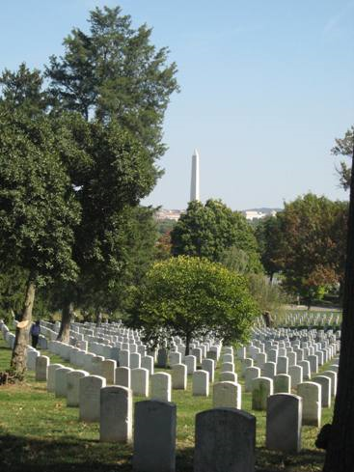

Arlington National Cemetery

Sponsored By
Lincoln Memorial Day Observance Association
Wyuka Cemetery & Funeral Home
Program Agenda

8:30 AM

Wreath Casting Ceremony to Honor the Sailors Dead
Connie Wright, NE DUVCW, Dept. President
Lincoln Air Force JROTC
Wreath Furnished by Petal Creations
Parade begins at Historic Stables and Bridge
Ron Lechner, Parade Chair
Procession to the G.A.R. Circle
Lincoln Fire & Rescue Pipe & Drum Corps
Color Guard
Lincoln Air Force JROTC
L.M.D.O.A Organizations

9:00 AM

Music by:
Midwest Sound & Lighting
CUMC Brass

Greetings & Introductions
Ed Hoffman, LMDOA Co-Chair
Welcome
Bob Fitzsimmons, Wyuka Trustee
Invocation
Pastor Tom Barber of Peoples City Mission
Pledge of Allegiance
John W. Brown, US Navy WWII
National Anthem
Staff Sergeant Anita Lovell
Acknowledgement of Veterans
Ed Hoffman, LMDOA Representative
General John A. Logan’s General Order #11
William Dean Commander Shiloh Camp, SUVCW
Decorating of the G.A.R. Circle
Christ School Girls Club
Guest Speaker
Brig Gen Daryl L. Bohac
Recognition of Memorials, Laying of the Wreaths
and Ringing of the Bell
Explanation of Releasing of the Doves
Firing Squad
VFW & American Legion
Releasing of the Doves by The Dove Barn
Taps Lumir Vajgrt & Jessica Bohlken
Benediction
Dr. Gary Fuller, Sr. Chaplain, Lincoln Chaplaincy Corps
Release of Memorial Balloons
Boy Scout Troop #456
Dismissal LMDOA Co-Chair
Lincoln Memorial Park & Funeral Home
Program Agenda

11:15 AM

Participants form and organize at the North parking lot of the Funeral Home and proceed to the
Circle inside Gate #2

Displays provided by the Art Class of Brenda Barnett
of Adams Elementary

Color Guard
Lincoln Air Force JROTC

11:30 AM

Greetings & Introductions
Ed Hoffman, LMDOA Co-Chair
Welcome
Reverend Ray Norris
Invocation
Dr. Gary Fuller, Sr. Chaplain, Lincoln Chaplaincy Corps
Pledge of Allegiance
John W. Brown, US Navy WWII
National Anthem
Staff Sergeant Anita Lovell
Acknowledgement of Veterans
Ed Hoffman, LMDOA Representative
In Flander’s Field
Poem by John McCrae, May 1915
Merle Rudebusch, Past Pres SAR, SUVCW
Placing of the Wreath
Ron Lechner, LMDOA Representative
General John A. Logan’s General Order #11
William Dean Commander Shiloh Camp, SUVCW
Guest Speaker
Brig Gen Daryl L. Bohac
Presentation of the Steven D. Gilbaugh Award
Gailen Young
Firing Squad
VFW & American Legion
Reading and Folding of the Flag
Ron Lechner (Reader)
Lincoln Air Force JROTC
Taps
Lumir Vajgrt
Benediction
Pastor Tom Barber of Peoples City Mission
Dismissal
LMDOA Co-Chair
Veteran’s Memorial Gardens
In Antelope Park
Program Agenda

7:30 Bag Pipes
Edwin Mukusha

8:00PM

Ringing of the Liberty Bell
Lincoln Parks & Recreation

Color Guard
Lincoln Air Force JROTC

Greetings & Introductions
Welcoming
Keith Fickenscher, Chairman VMGAC

Pledge of Allegiance
John W. Brown, US Navy WWII

National Anthem
Bruce Ericksen, Drew & Deepa Buss

Invocation
Pastor Rick Kelly Chaplain, Lincoln Chaplaincy Corps

Guest Speaker
Brig Gen Daryl L. Bohac

Acknowledgement of Veterans
Jess Smith, Vice Chair VMGAC

Candlelight Service
VVA Chapter 727

Reading of Names
Diane Bartels, Ron Lechner,
Rebecca Bowman, Hoot Gibson,
Kathy Drucker, Brendan Moore,
Dorothy Anderson

Some Gave All
Bruce Ericksen, Drew & Deepa Buss

Taps
Lumir Vajgrt
Retire Colors

Benediction
Pastor Rick Kelly Chaplain, Lincoln Chaplaincy Corps

Dismissal
Keith Fickenscher, Chairman VMGAC

In case of inclement weather we will move
into the shelter building

